Functionalities:
TOP PORTION:
- Logo for the website
- Social Integration – In this add a mail box, that can have the details
- Full name, e-mail, name of the organization, query which should come to an e-mail info_b2b@polyvalent.co.in
- Have Social Handles in white color
- Could see a gap in the starting of the website, what is that!
- There is also some white space at the end of the blue strip carrying the name and Social Handles. It has to be completed
- SME to be changed to SMEs
- Ticker for SENSEX

Middle Portion:
- Main story: Below the image, the heading of the article should there and link to the respective section.

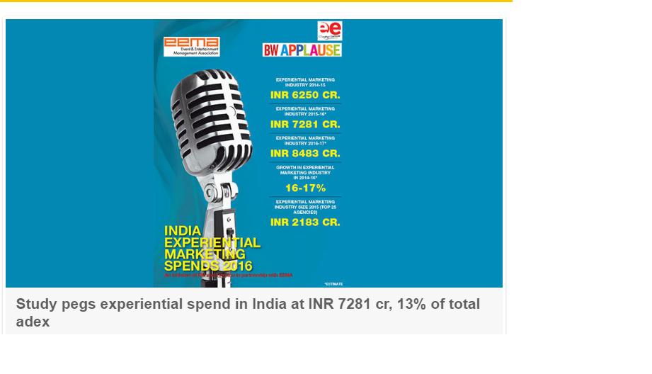
- Cut down short and crisp to 4, as I want some content to be displayed as well
- For twitter, have the logo in white color (Click here to follow us….)
- Increase the size of Market analysis and level it up till the twitter section

Landing pages:
Indivisual landing page:-
Whenever the link is clicked, the format should be like:
- Date and name of the author
- Heading of the article ( That should be Bold)
- A brief introduction ( 5-6 lines)
- And then the remaining story ( along with the picture)
- The bottom should have sharing option through the social media links- ‘Share this article’
SAMPLES:
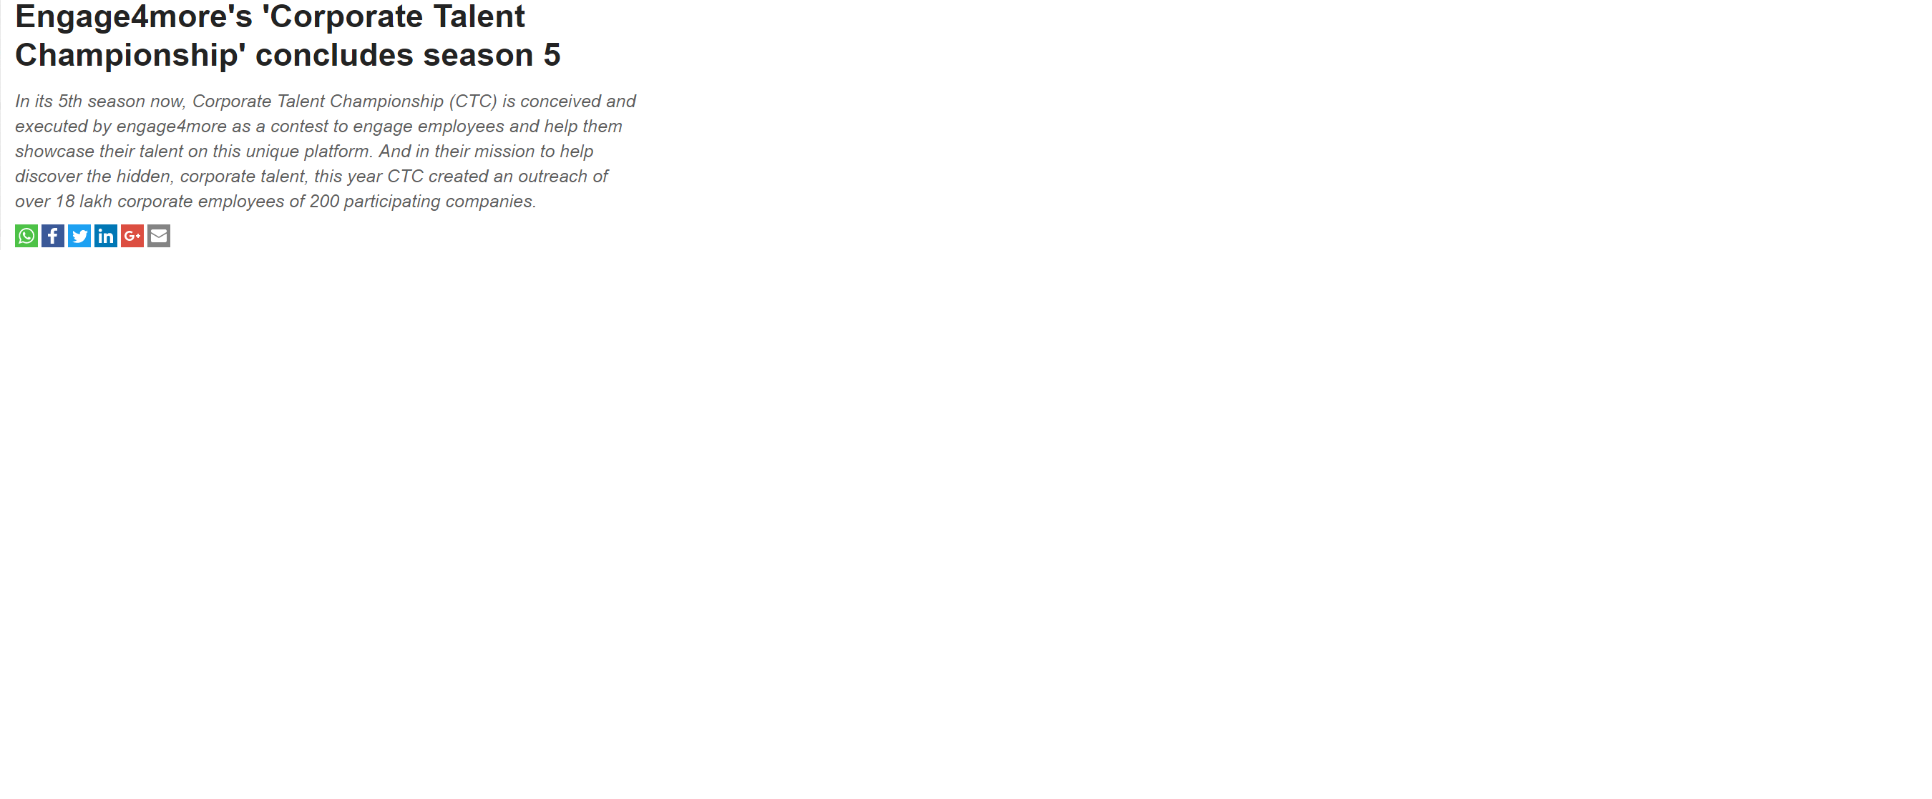
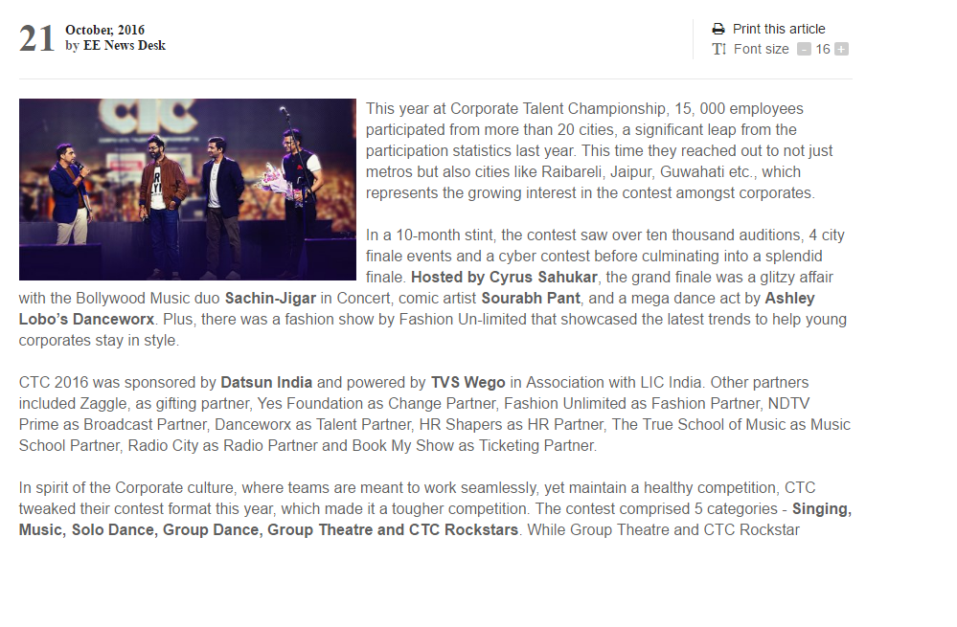

Individual landing pages:
- Image, heading and content, with a read more option. The read more to again land to the pages as arranged in the above format
SAMPLE
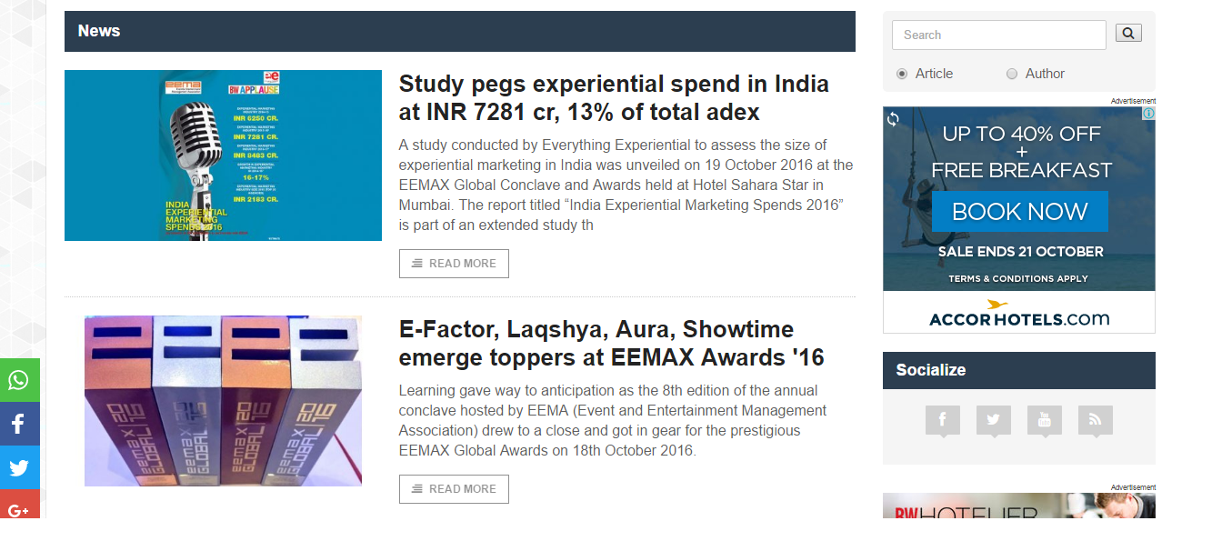
For all the pages, other than news, the name of the author has to appear
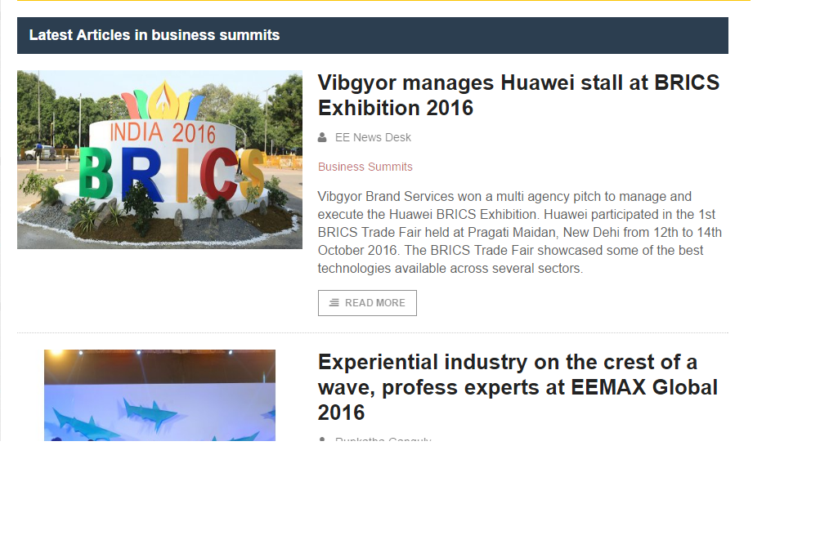
ON THE RIGHT HAND SIDE:
- Every section to have a tab called, ‘You might also like’ that has the links for the stories of that section. It should cover half of the page
- The second tab should be ‘Recently Published’ that will have the links of the articles published on that very day!

